Recess
Pre order not necessary
BIRTHDAY BUCKET $20
Buy a class set of icy poles to help celebrate a special day
PREORDER BY WED to avoid disappointment
Biscuits x 2 50c
Milo Balls x2 $1.00
Pikelets x 2 50c
Popcorn 50c
Cheesies $1.00
plain cheese, spaghetti, or baked beans
Icy Poles $1.00
Drinks
Milk 250ml $2.00
Chocolate or Strawberry
Fruit Box $1.50
Water $1.00
Online ordering-
www.quickcliq.com.au
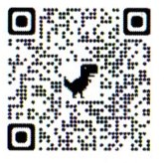
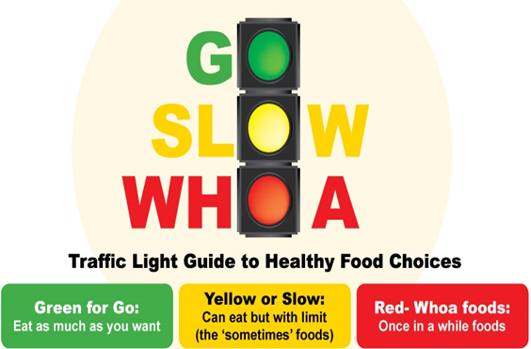

Lunch Menu – Online orders close
Please order by first bell
* all available with Ham, Chicken, or tuna
for additional $1.00**
*Toasties
Cheese $3.00
Tomato & Cheese $3.50
*Sandwiches and wraps $3.00
*Salad and egg bowls
Lettuce, carrot, cucumber, tomato
small $2.50
large $3.50
Hotdog
1/2 $3.00
Whole $5.00
Mac & Cheese
small $3.00
large $5.00
Chicken Nuggets
4 nuggets $3.00
8 nuggets $5.00
Hamburgers
with cheese $3.00
with salad $5.00
(Lettuce, carrot, cucumber, tomato)

